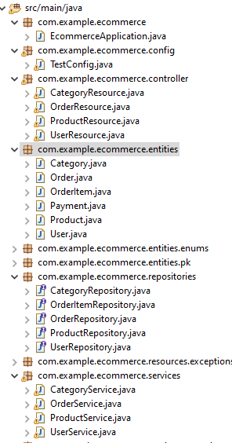

Layout of Packages in Eclipse (atleast 3 entities)

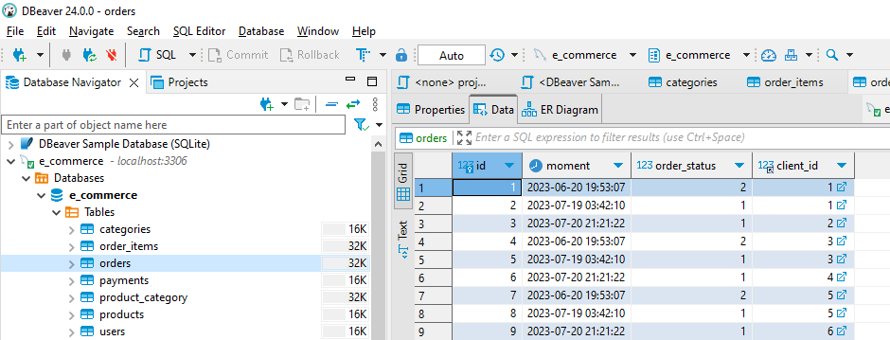

Corresponding tables getting populated in Dbeaver

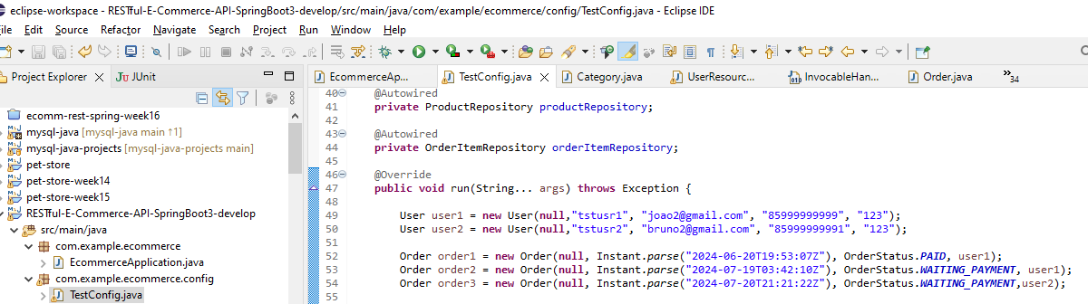

One to Many junit code snippet

User1 is creating two orders

User2 is creating one order

Here are corresponding DBeaver records:

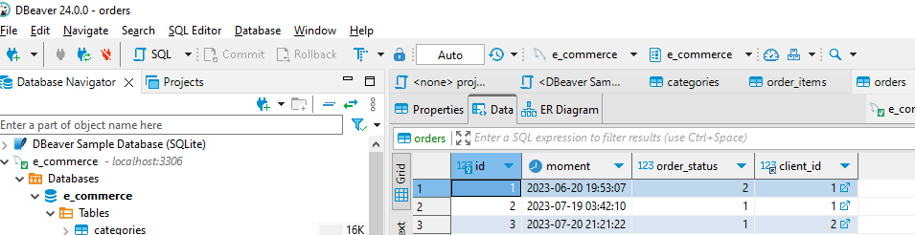

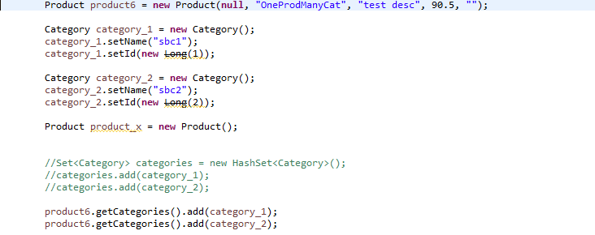

One product can have many categories. Added via junit test

Product6 has “sbc1”, “sbc2” categories

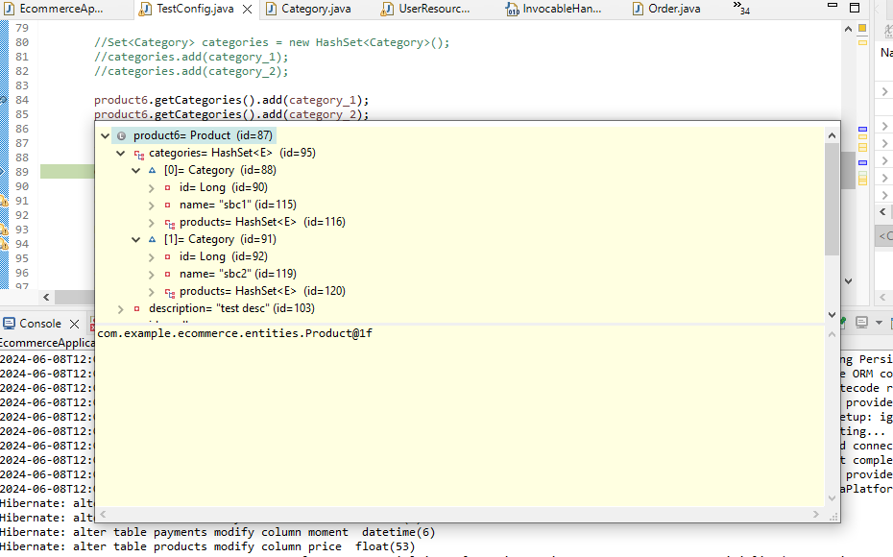

Shown in Debug mode

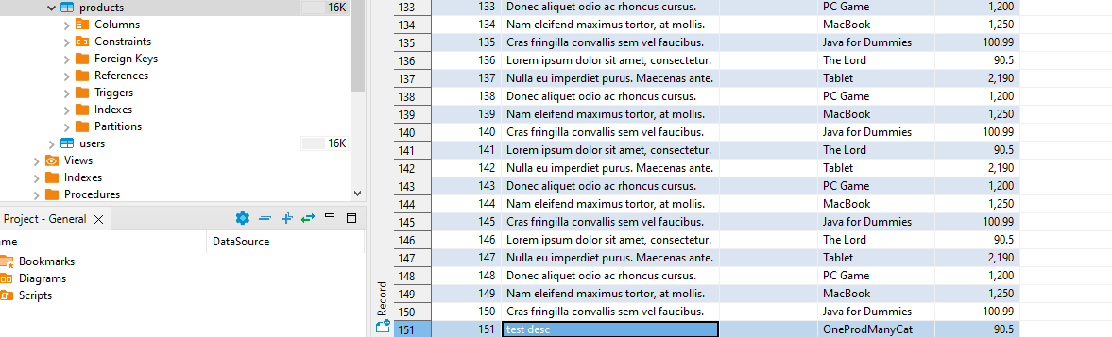

Corresponding record via DBeaver (id = 151 last record))

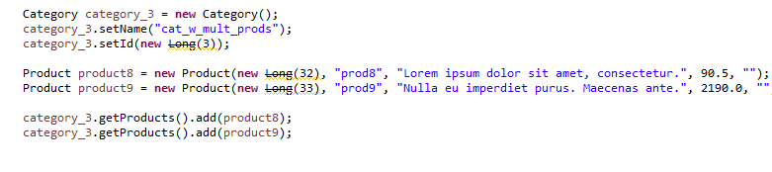

One Category to Many products (Junit code snippet)

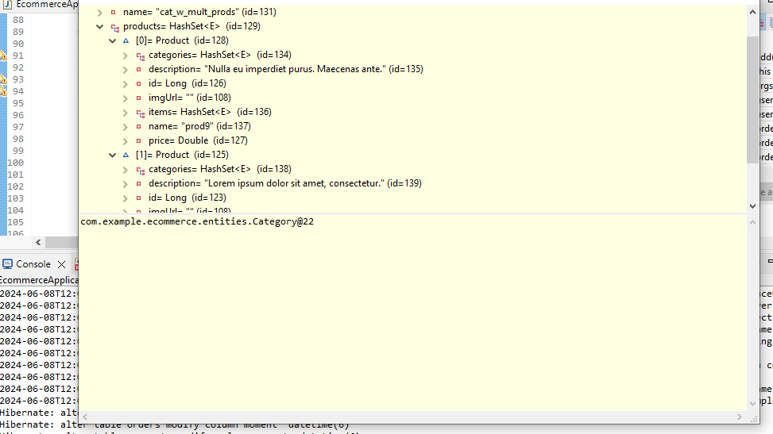

One Category to many products (shown in debug mode)

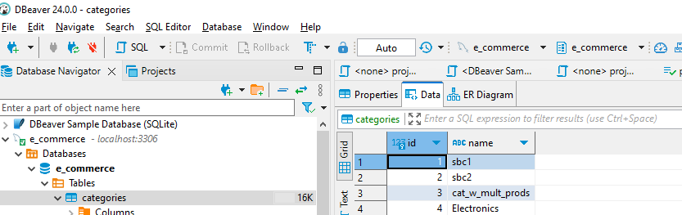

Corresponding Category records via DBeaver

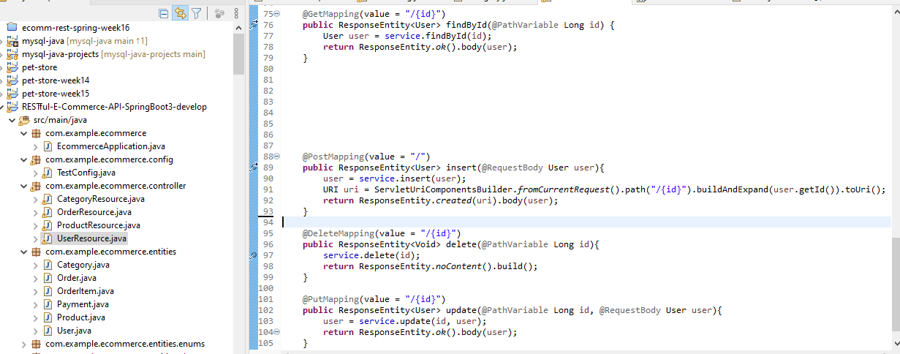

User Table has supports 4 CRUD operations (shown via UserResource.java controller layer)

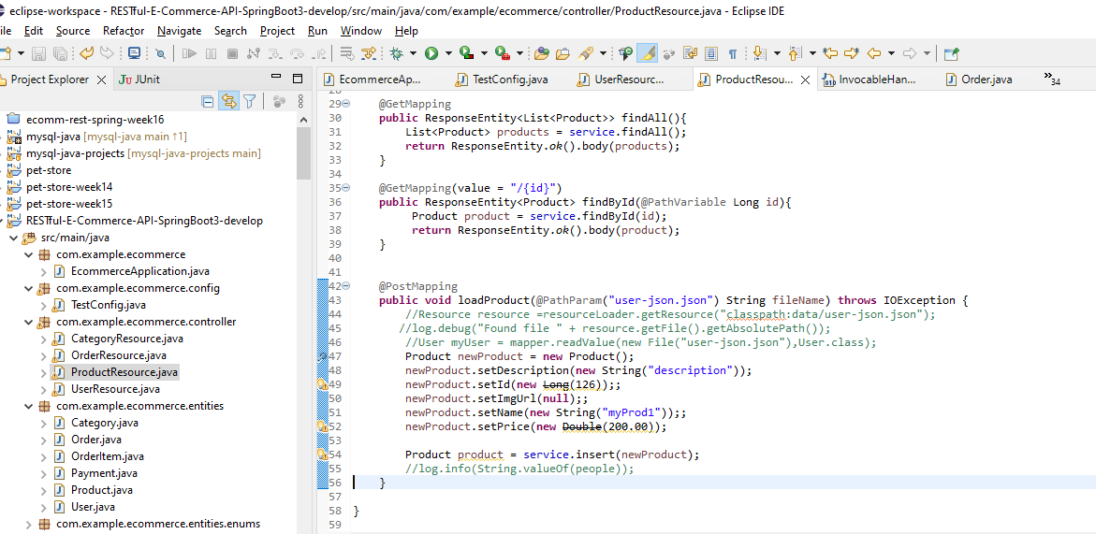

Product Table supports Insert/Load Product operation (shown via ProductResource.java controller layer)

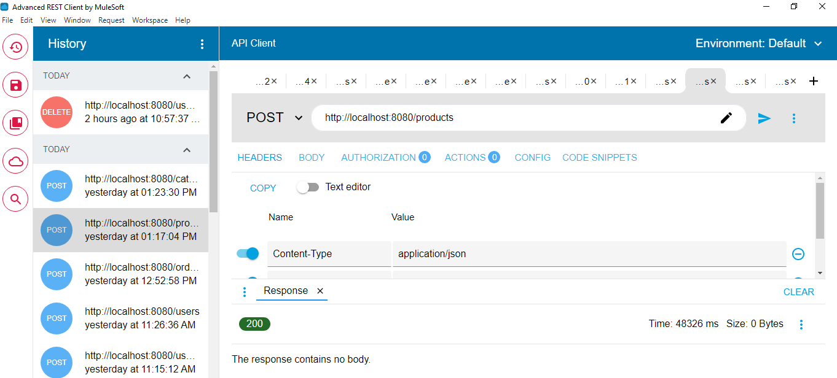

ARC POST request for adding a new Product which gets added to Dbeaver

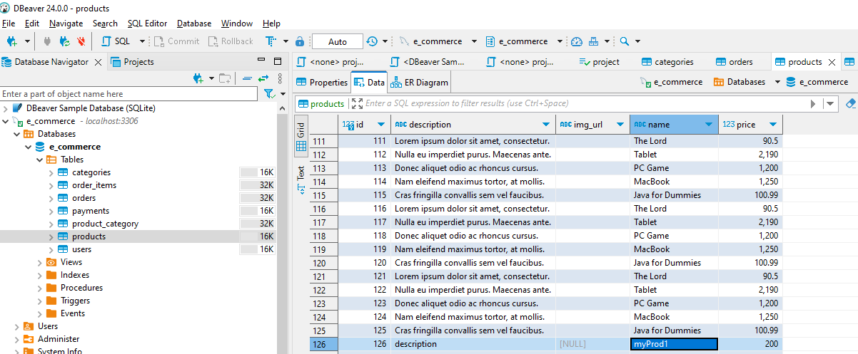

Corresponding myProd1 created in Dbeaver via Postmapping

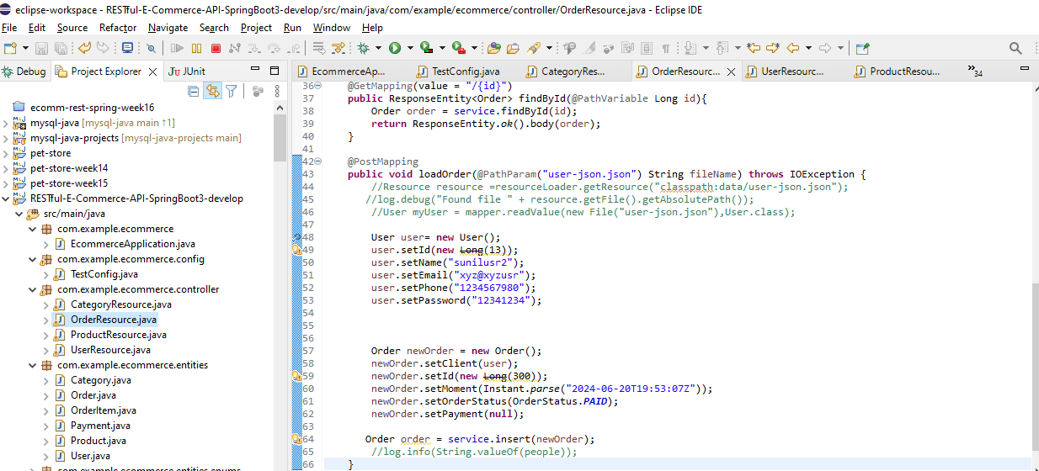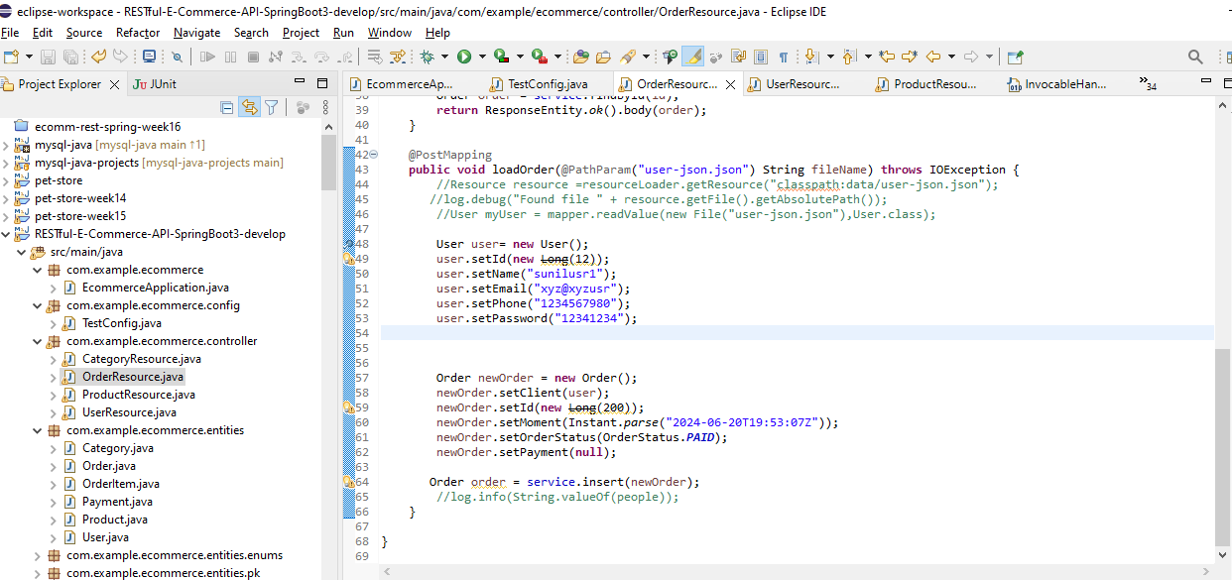

Order Table supports Insert/Load Order operation (shown via OrderResource.java controller layer) PostMapping which gets triggered via ARC

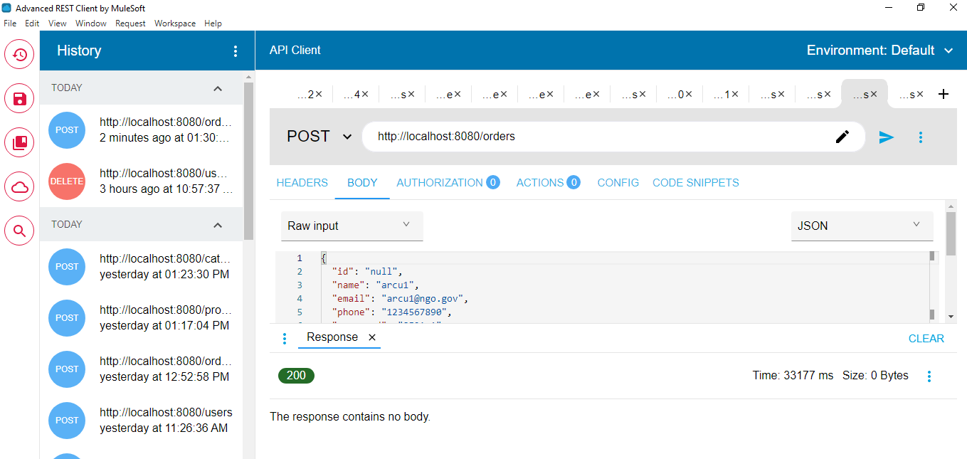

Corresponding Order record shown in DBeaver (last record with id = 13, timestamp matches input test data)

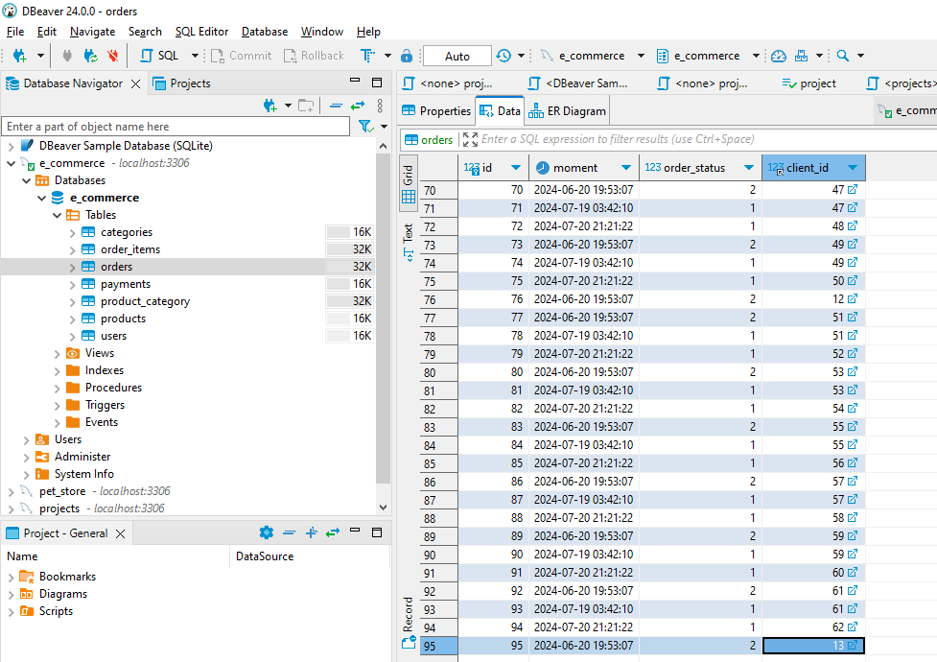

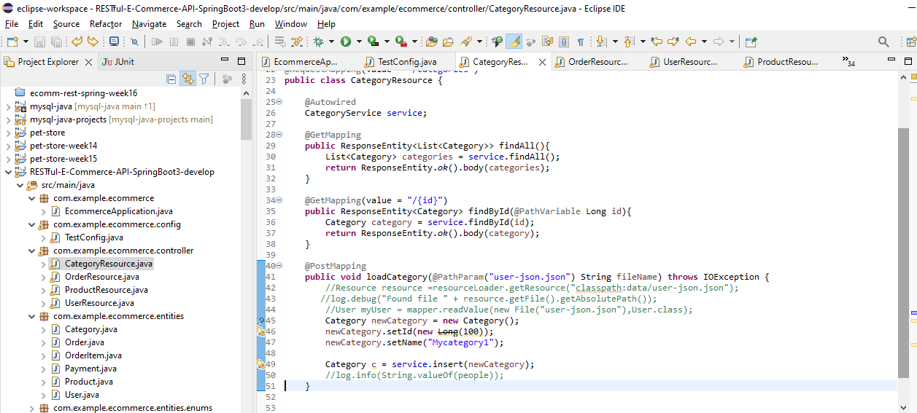

Category Table supports Insert/Load Order operation (shown via CategoryResource.java controller layer)

Which gets triggered via ARC PostMapping

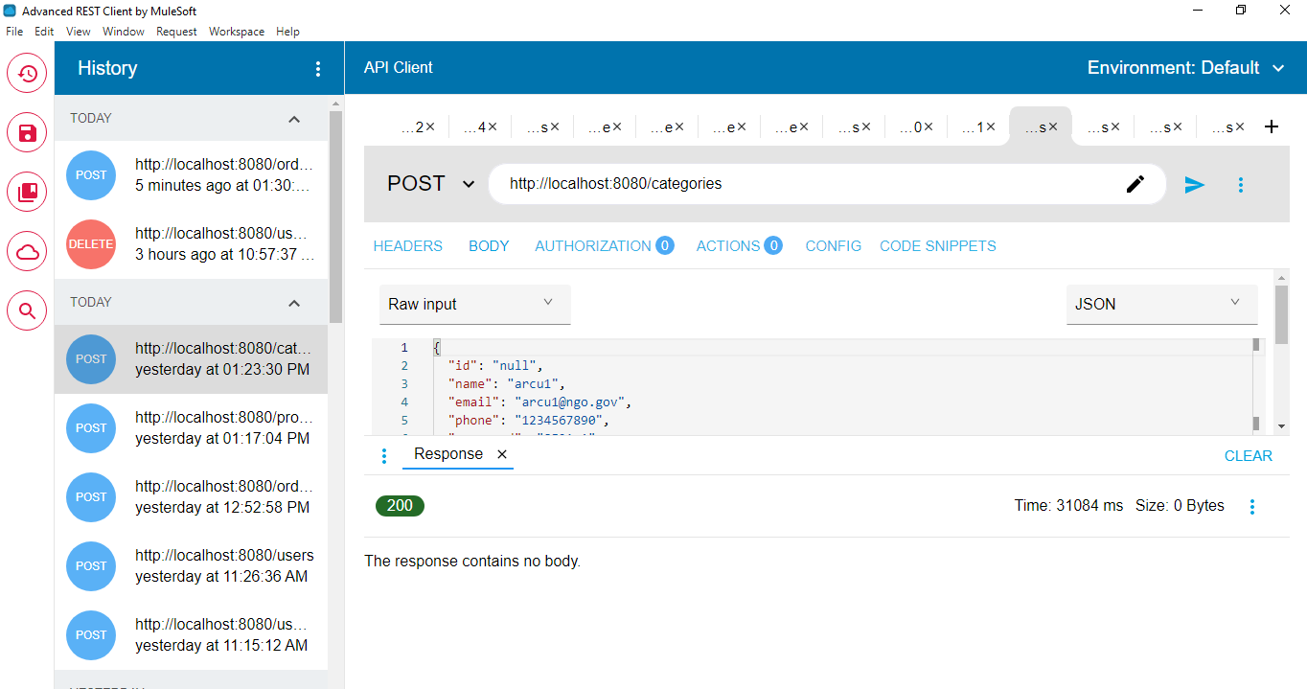

And corresponding DBeaver record with id=82 you could refer to test data in previous screen

